<https://github.com/AlanFahy87/ct331_assignment1/tree/master/src>

Q1



Q2

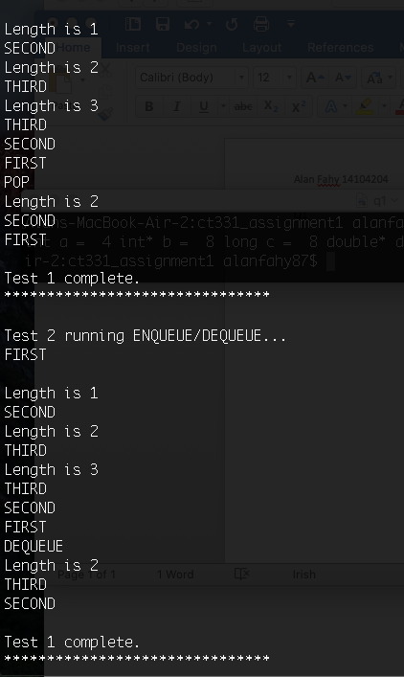

Q3

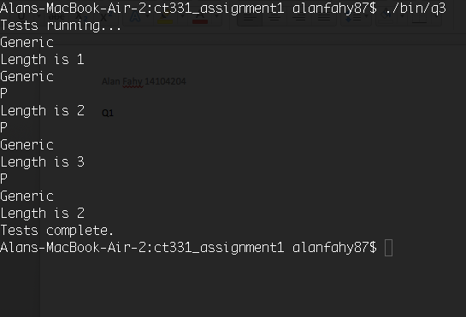

Q4

1, Because linked lists are sequential, it would have to go all the way to the end of the list before traversing from tail to head using more memory to store the pointers.

2. DoubleLinkedList could be a solution as it uses backwards pointers easily to reverse through the list.